

Semester Two Examination 2017

Question/Answer Booklet

MATHEMATICS
METHODS UNITS 3 & 4

Section Two:
Calculator-assumed

Student Name: _____________________________________

Teacher’s Name: _____________________________________

Time allowed for this section
Reading time before commencing work: ten minutes
Working time for paper: one hundred minutes

Material required/recommended for this section

To be provided by the supervisor
This Question/Answer booklet
Formula Sheet (retained from Section One)

To be provided by the candidate
Standard items: pens(blue/black preferred), pencils(including coloured), sharpener, correction tape/fluid, erasers, ruler, highlighters

Special Items: drawing instruments, templates, notes on two unfolded sheets of A4 paper, and up to three calculators approved for use in the WACE examinations.

Important note to candidates
No other items may be taken into the examination room. It is your responsibility to ensure that you do not have any unauthorised notes or other items of a non-personal nature in the examination room. If you have any unauthorised material with you, hand it to the supervisor before reading any further.

Structure of this paper

 | Number of questions available | Number of questions to be attempted | Working time (minutes) | Marks available | Percentage of exam
Section One  Calculator—free | 8 | 8 | 50 | 50 | 35
Section Two  Calculator—assumed | 12 | 12 | 100 | 98 | 65
 |  |  |  |  | 100

Instructions to candidates

- The rules for the conduct of Western Australian external examinations are detailed in the Year 12 Information Handbook 2017. Sitting this examination implies that you agree to abide by these rules.

- Answer the questions according to the following instructions.

Section Two: Write answers in this Question/Answer Booklet. Answer all questions.

Show all your working clearly. Your working should be in sufficient detail to allow your
answers to be checked readily and for marks to be awarded for reasoning. Incorrect
answers given without supporting reasoning cannot be allocated any marks. For any
question or part question worth more than two marks, valid working or justification is required to receive full marks. If you repeat an answer to any question, ensure that you cancel the answer you do not wish to have marked.

It is recommended that you do not use pencil, except in diagrams.

- You must be careful to confine your responses to the specific questions asked and to follow any instructions that are specific to a particular question.

- Spare pages are included at the end of this booklet. They can be used for planning your responses and/or as additional space if required to continue an answer.
- Planning: If you use the spare pages for planning, indicate this clearly at the top of the page.
- Continuing an answer: If you need to use the space to continue an answer, indicate in the original answer space where the answer is continued, i.e. give the page number. Fill in the number of the question that you are continuing to answer at the top of the page.

- The Formula Sheet is not handed in with your Question/Answer Booklet.

Section Two: Calculator–Assumed 98 marks

This section has twelve (12) questions. Attempt all questions. Write your answers in the spaces provided.

Spare pages are included at the end of this booklet. They can be used for planning your responses and/or as additional space if required to continue an answer.

- Planning: If you use the spare pages for planning, indicate this clearly at the top of the page.
- Continuing an answer: If you need to use the space to continue an answer, indicate in the
original answer space where the answer is continued, i.e. give the page number. Fill in the
number of the question(s) that you are continuing to answer at the top of the page.

Working time: 100 minutes

Question 9 (7 marks)

The rate of decay of a radio-active substance is often measured in terms of its half−life.
This is the time (t years) for half of its mass to decay.
The formula can be expressed as M = M₀ e^{−kt} where M₀ is the original mass and k is a constant.

Initially there is 20 units of mass, and when t = 2, M = 0.9M₀ units of mass.

(a) Show that k = 0.0527 to 3 significant figures. (2 marks)

(b) Determine the half−life of this substance. (2 marks)

(c) Determine the rate at which the mass is changing when t = 2. (3 marks)

Question 10 (9 marks)

On a cruise ship, there are some married couples and many single travellers.
At dinner one evening, it was noticed that there were 8 married couples out of a sample 40 diners. The other diners were single travellers.

(a) State why the selection of each diner is an example of a Bernoulli trial. (1 mark)

(b) State the proportion of single travellers at dinner. (1 mark)

(c) Determine the standard deviation of the sample proportion of single travellers. (2 marks)

(d) Calculate a 95% confidence interval for the true proportion of single travellers on board.

(2 marks)

If we want the margin of error to be made much smaller, while still keeping the 95%
confidence interval, we need to take a larger sample.

(e) What size sample needs to be used to make the margin 5%? (3 marks)

Question 11 (9 marks)

(a) Use your calculator to determine 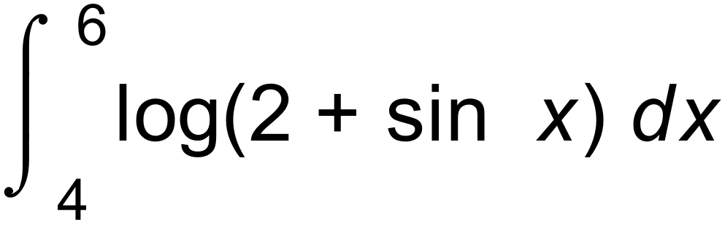 correct to 3 decimal places.
(1 mark)

(b) Use your calculator, or your knowledge of the log function and the sine function, to determine the minimum value of log( 2 + sin x). (2 marks)

(c) Sketch the graph of y = log(2 + sin x), showing its major features. (3 marks)
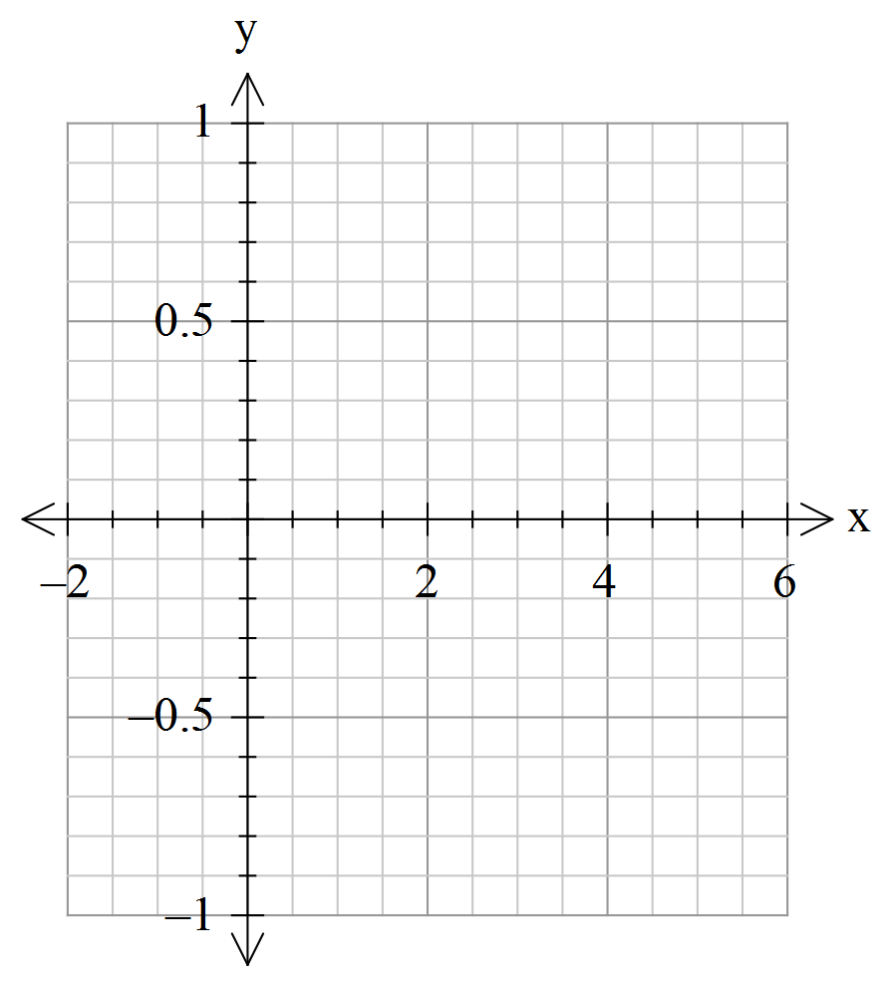

(d) Determine the area under the curve y = log  between x = 4 and x = 6
and the x axis. Show your working. (3 marks)

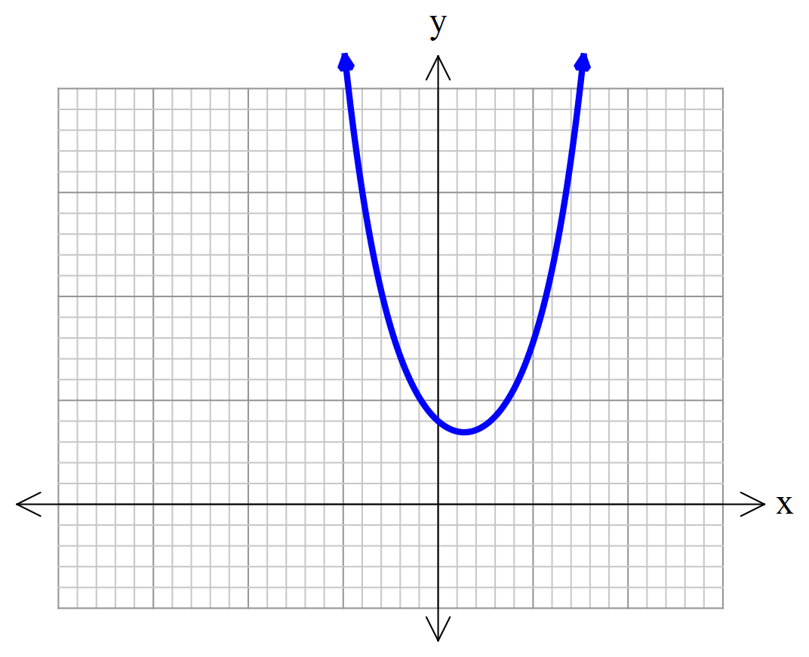Question 12 (9 marks)

A function f (x) is graphed below.

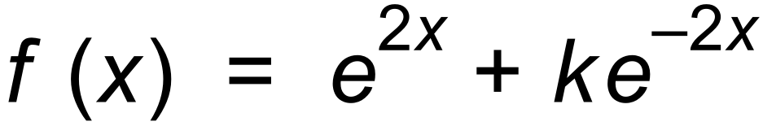 where k is a constant greater than 1.

(a) Determine the range of f in terms of k. (4 marks)

(b) (i) If k = 3, determine by the method of small change an approximate value for the
change in f (x) when x changes from 2 to 2.01 (3 marks)

(ii) Use your calculator to find the exact value of f(2.01) – f(2) (2 marks)

Question 13 (8 marks)

A tetrahedral die has the numbers 1 to 4 on its four faces. When the die is thrown, the uppermost
face shows a score, X, with probability distribution as shown in the table.

x | 1 | 2 | 3 | 4
P(X = x) |  |  |  | 

Throws of the die are independent.

(a) John believes that this die is biased. Comment on John’s belief. (1 mark)

(b) Determine the probability that a throw results in a score less than 4. (1 mark)

(c) Calculate E(X) and Var(X). (2 marks)

The die is thrown 5 times.

(d) Find the probability that four of the throws result in a score of two.
(2 marks)

(e) Find the probability that a total of 20 is scored. (2 marks)

Question 14 (9 marks)

These results are from an experiment to see how the sag of a beam (z cm) is related to the distance between supports for the beam (d cm).
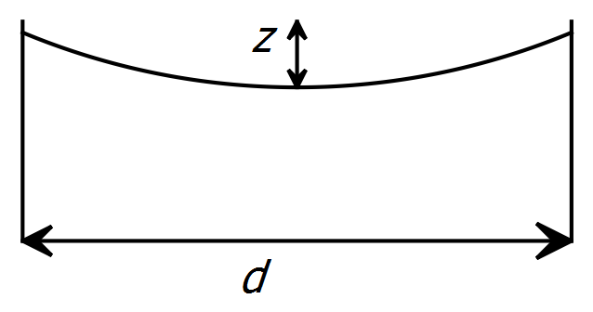

z | 1.1 | 1.3 | 1.7 | 2.0 | 2.4
d | 130 | 220 | 490 | 800 | 1400
Log z | 0.0414 | 0.1139 | 0.2305 | 0.3010
Log d | 2.11 | 2.34 | 2.69 | 2.90

(a) Complete the table. (2 marks)

(b) Enter the data onto the axes below, and draw a line that seems to fit well through the
points you have graphed. (3 marks)

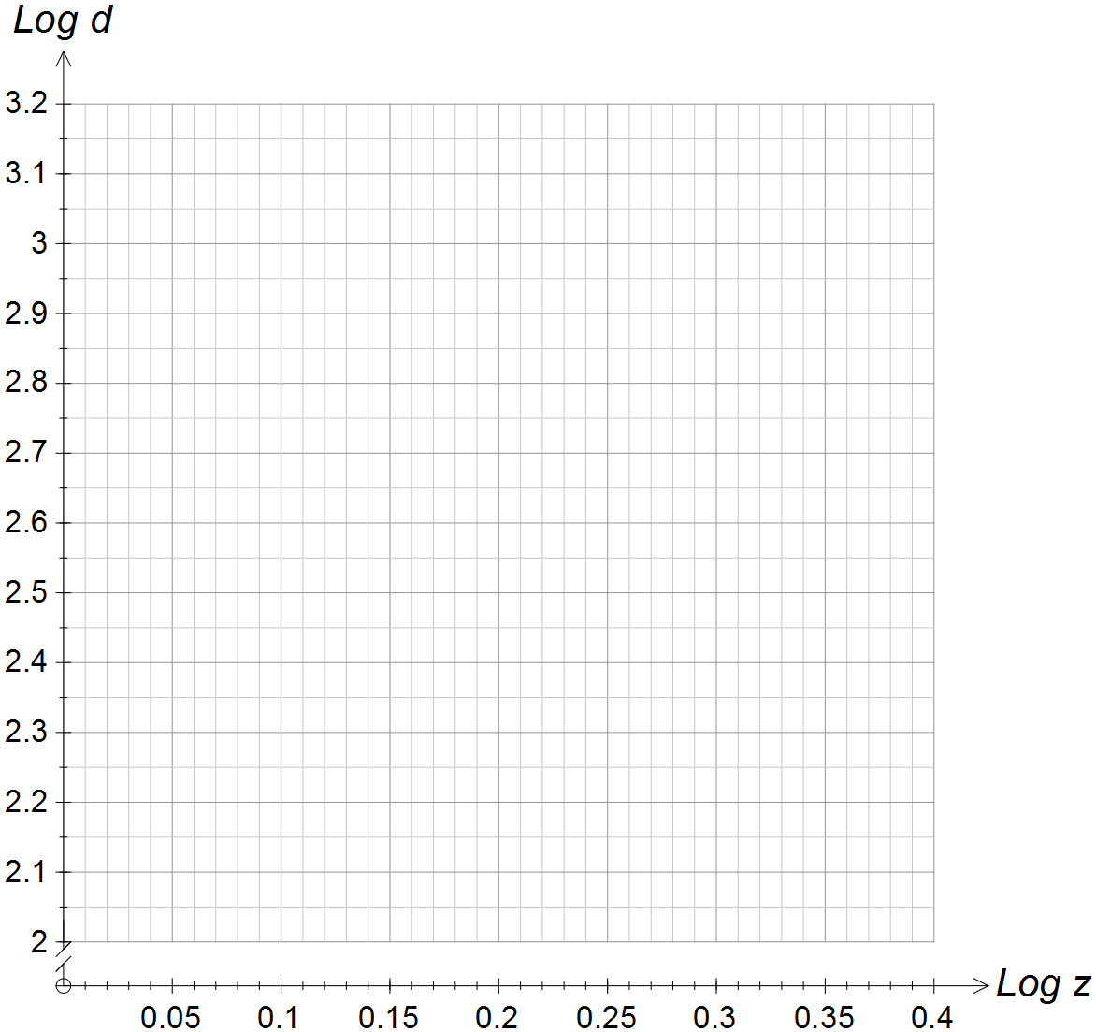

(c) Determine the equation of the line you have drawn in the form
log d = a + b log z . Round the values of a and b to the nearest whole number. (2 marks)

(d) Hence, determine the equation which relates d and z. (2 marks)
Question 15 (5 marks)

In triangle PQR, PQ = 3 cm, QR = 5 cm and the size of angle Q is  as shown.
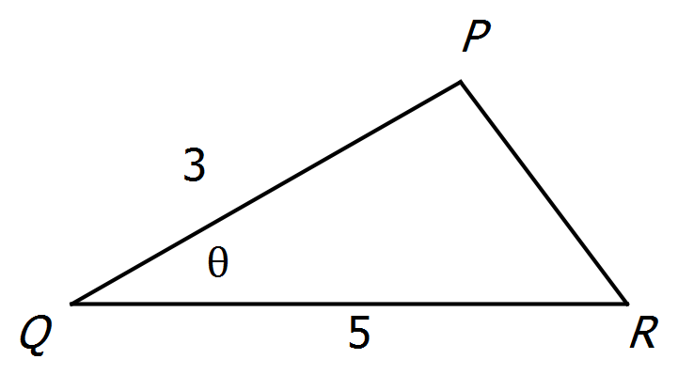

(a) Show that the rate at which the area is changing with respect to 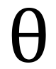 is 7.5cos . (2 marks)

(b) If  is increasing at 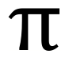 radians/second, use the Leibnitz formula (chain rule) to find the
rate of change of the area of the triangle with respect to time when 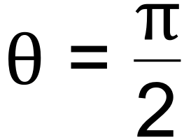 . (2 marks)

(c) Interpret your answer to (b). (1 mark)

Question 16 (7 marks)

A continuous random variable is uniformly distributed in the interval 3 ≤ X ≤ 9.

(a) Determine P(X < 5). (1 mark)

(b) Determine P(X < 5 | X < 6). (2 marks)

(c) Calculate the mean and standard deviation of X. (2 marks)

(d) If Y = 2X + 5, determine the mean and standard deviation of Y. (2 marks)

Question 17 (6 marks)

The mass of a box of Daffodils chocolates (D) is a normally distributed random variable
with mean of 400 grams and standard deviation of 50 grams.

(a) Determine the probability that a randomly selected box of Daffodils has a mass
between 390 g and 410 g. (1 mark)

The manufacturers guarantee that at least 92% of all boxes of Daffodils have a mass
between (400 – k) and ( 400 + k) grams.

(b) Determine the value of k. Show your working. (3 marks)

Large boxes of Daffodils (LD) have a mean mass of m grams and a standard deviation of s grams.
The relationship between the mass of boxes of Daffodils and the mass of large boxes of Daffodils
is 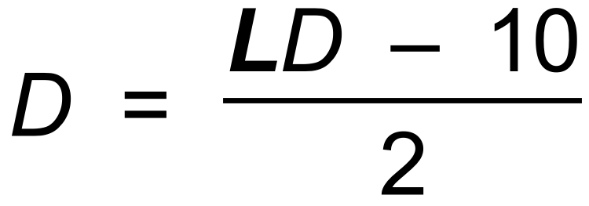 .

(c) Determine the values of m and s. (2 marks)

Question 18 (8 marks)

The displacement, x metres, of a body from an origin, O, is given by
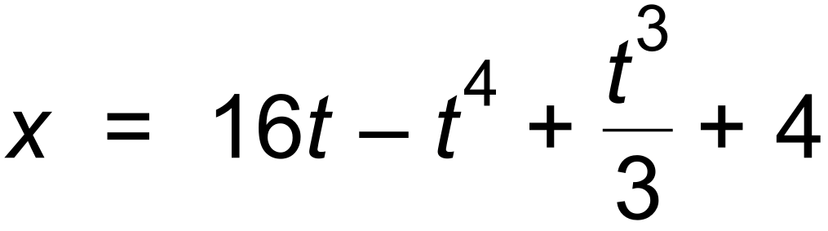 and t is the time in seconds after passing O.

Determine:

(a) the values of t when acceleration is zero. (2 marks)

(b) the value(s) of t when the body is at rest. (2 marks)

(c) the displacement when the acceleration is a maximum. (2 marks)

(d) the total distance travelled in the first 2 seconds. (2 marks)

Question 19 (8 marks)

When sampling solar panels, it is found that 7% are defective.

Three hundred panels are selected at random from that distribution. The proportion of defective panels is recorded. This process is repeated many times and the resultant proportions are graphed.
(a) Identify the shape of the graph of the sample proportions. (1 mark)

(b) Determine the mean and standard deviation of the number of defective panels in
one sample. (2 marks)

(c) Determine the mean and standard deviation of the sample proportions.
(3 marks)

It was found that in a sample of three hundred panels, forty five were defective.

(d) Interpret this result. (2 marks)

Question 20 (13 marks)

Birthday crackers are meant to contain a printed joke. However it is found that in a box of 100,
2% are blank.

(a) Identify the probability distribution of X = the number of blank jokes in a box of crackers
and also give the mean and standard deviation. (3 marks)

(b) Determine the probability that there are at least 5 blanks in a randomly selected box. (2 marks)

Samples of 20 boxes are collected and the number of blanks recorded.

(c) Determine a 90% confidence interval for the proportion of blanks in a sample of 20 boxes, assuming that 2% are blank. (2 marks)

(d) Three samples are collected and a 90% confidence interval is calculated each time.
Determine the probability that exactly two of these intervals will contain the true value
0.02 of the proportion of blanks. (2 marks)

(e) Using your 90% confidence interval from part (c), determine the range in which the expected number of blanks in a sample of 20 boxes would lie. (2 marks)

Five samples, each of size 20 boxes, have the number of blanks recorded as shown in the table.

Sample | 1 | 2 | 3 | 4 | 5
No of blanks | 45 | 57 | 28 | 46 | 49

(f) Decide which samples lie outside the 90% confidence interval, if any. Justify your answer.
(2 marks)

END OF QUESTIONS

Additional working space

Question number(s): ……………………

